Regional Overview
Introduction
The subject is located in the Corpus Christi Metropolitan Statistical Area (MSA) Workforce Development Area (WDA). The Corpus Christi MSA includes the following three counties: Aransas, Nueces, and San Patricio.
The region is coastal in character and situated along the Texas Gulf Coast in South Texas, approximately 210 miles southwest of Houston and 140 miles southeast of San Antonio. The primary population and employment center is Corpus Christi, the largest city in the Coastal Bend region. The regional economy is anchored by energy production and export, port operations, petrochemical manufacturing, healthcare services, military installations, tourism, and government-related employment.
The Corpus Christi MSA functions as a major regional economic hub and the nation's leading crude oil export gateway, serving both domestic and international markets through the Port of Corpus Christi. The region benefits from its strategic Gulf Coast location, robust transportation infrastructure, and a growing industrial base driven by energy sector investment.

Regional Map
<TODO: Insert Map>
The following information is from the Corpus Christi MSA Labor Market Profile, published by the Texas Workforce Commission (December 2025)
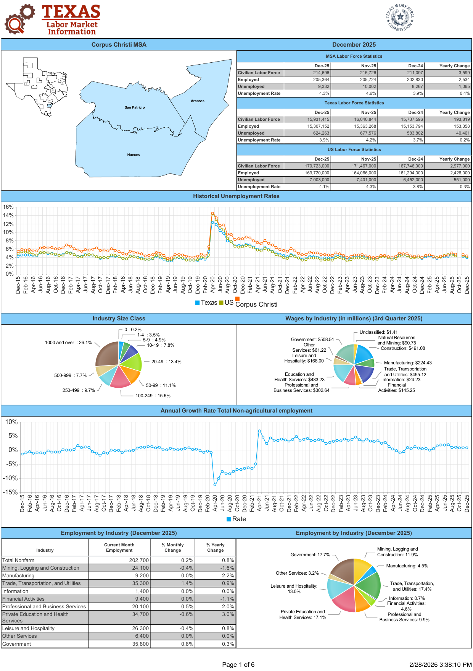
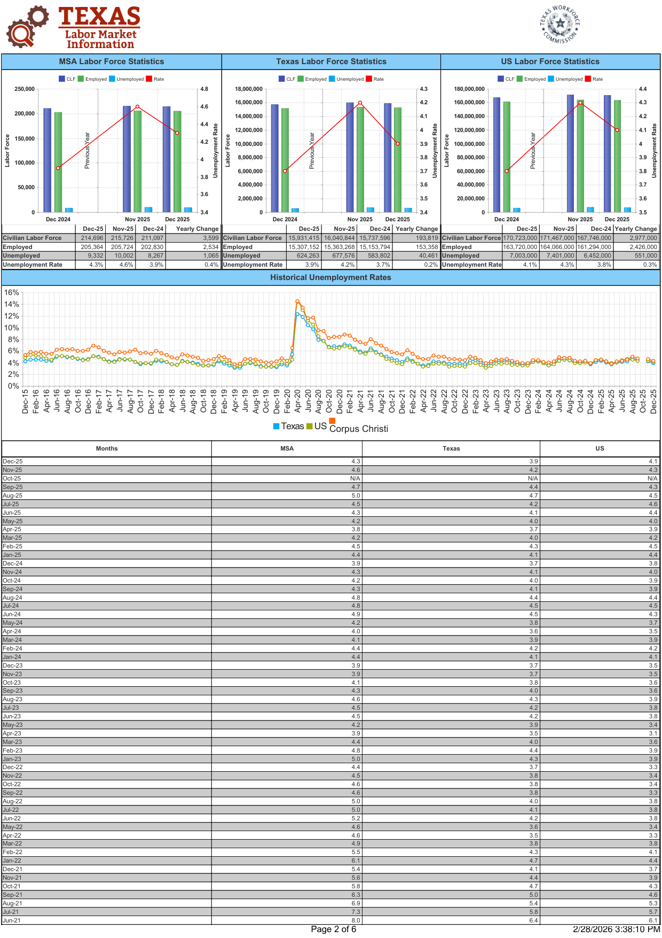
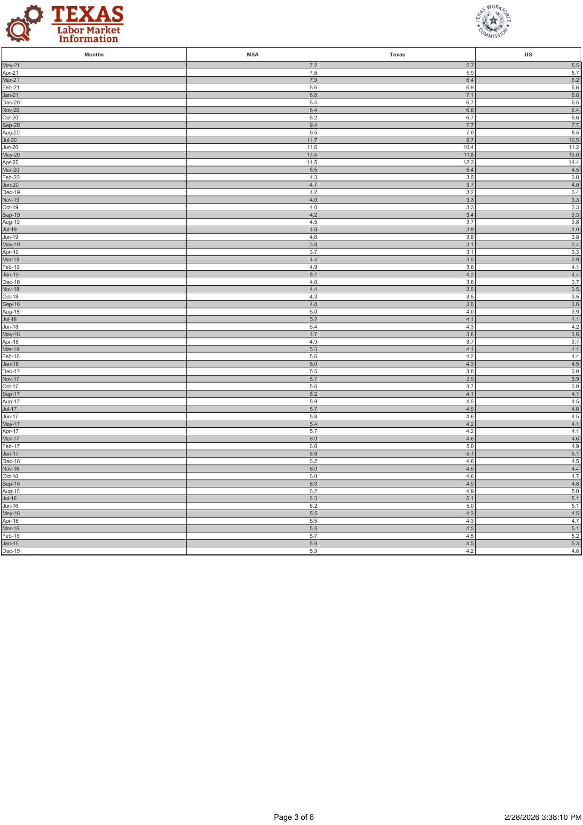
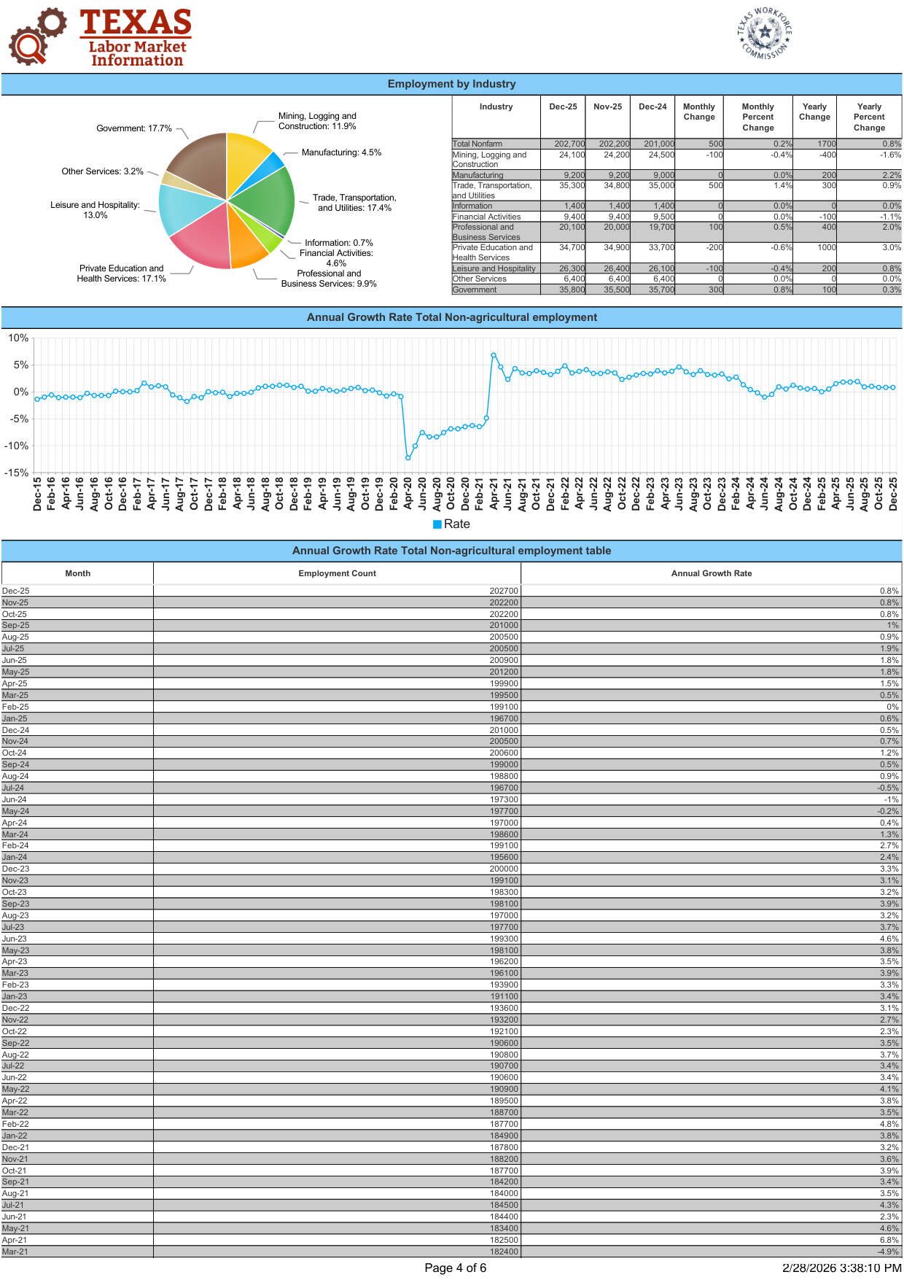
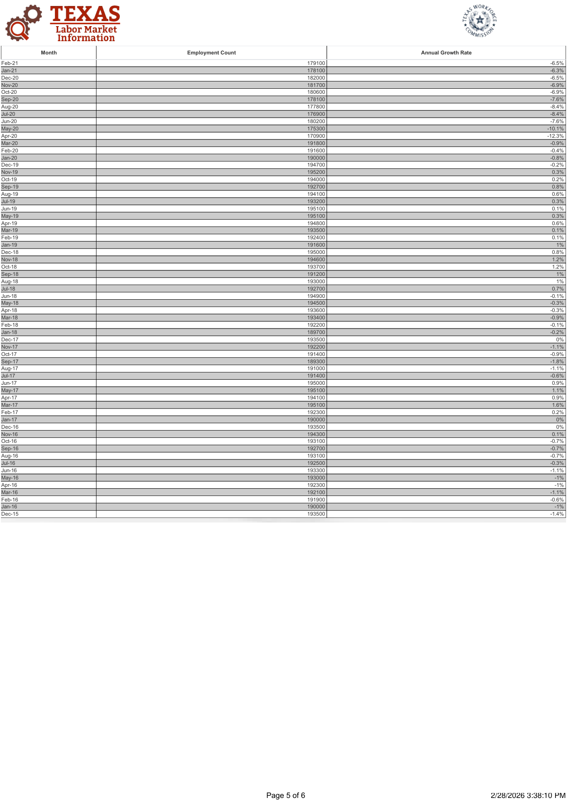
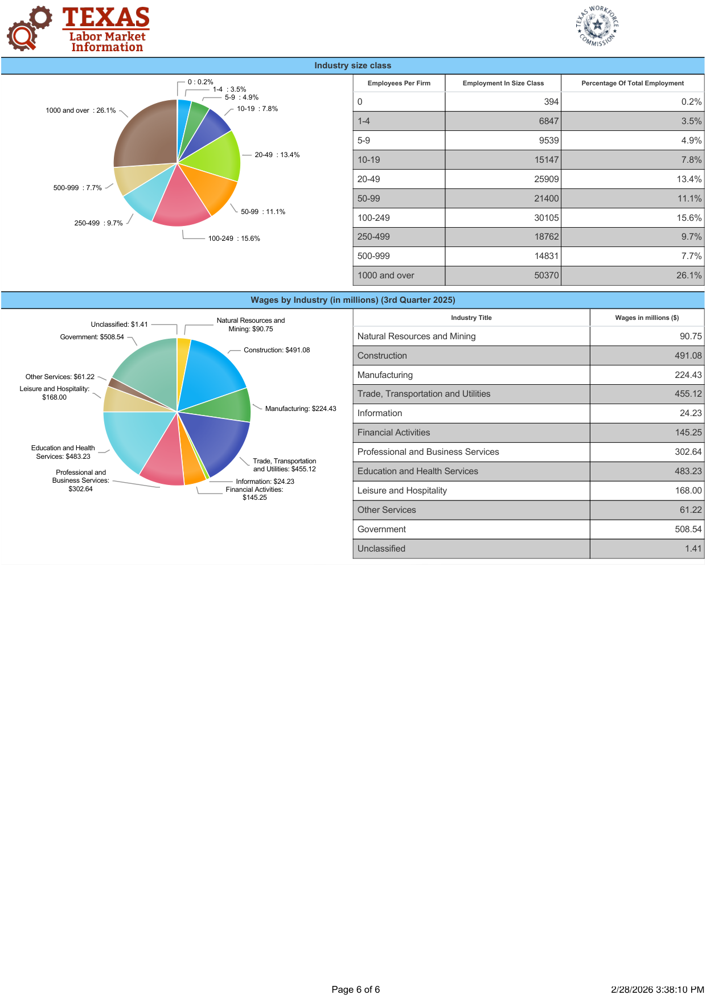
Labor Force
As of December 2025, the Corpus Christi MSA had:
• Civilian Labor Force: 214,696
• Employed: 205,364
• Unemployed: 9,332
• Unemployment Rate: 4.3%
The unemployment rate of 4.3% is above the Texas average of 3.9% and the national average of 4.1%, indicating a modestly higher level of labor market slack compared to broader state and national economies. The Corpus Christi MSA labor force grew by approximately 3,599 workers year-over-year, reflecting continued regional population and employment expansion.
The estimated average weekly wage for the Corpus Christi MSA in Q3 2025 was approximately $1,133, derived from aggregate covered wages of approximately $2.96 billion in the quarter. While below the Texas average of $1,444, wages reflect the region's mix of high-paying energy and construction positions offset by a significant share of service, hospitality, and trade employment.
Industry Overview
The Corpus Christi MSA maintains a diversified employment base anchored by government services, energy and construction, trade, and healthcare. As of December 2025, the largest employment sectors included:
Government – 17.7%
Trade, Transportation and Utilities – 17.4%
Private Education and Health Services – 17.1%
Leisure and Hospitality – 13.0%
Mining, Logging and Construction – 11.9%
Professional and Business Services – 9.9%
Financial Activities – 4.6%
Manufacturing – 4.5%
Other Services – 3.2%
Information – 0.7%
Government, Trade/Transportation, and Private Education/Health together account for approximately 52.2% of total employment, underscoring the region's reliance on public-sector services, wholesale and retail trade, port-related logistics activity, and healthcare.
Mining, Logging and Construction represents a significant 11.9% of employment, reflecting the ongoing strength of the energy sector and active construction activity tied to port expansion, petrochemical facility development, and major infrastructure investment including the Harbor Bridge Replacement Project.
Leisure and Hospitality accounts for 13.0% of employment, consistent with Corpus Christi's role as a major Gulf Coast tourism and hospitality destination, supported by beaches, bay access, and the Texas State Aquarium.
Employment Trends and Projection
Between 2022 and 2032, the fastest-growing industries in the Corpus Christi MSA are projected to include:
Support Activities for Oil and Gas Extraction – 22.5%
Individual and Family Services – 21.3%
Offices of Physicians – 19.8%
Child Care Services – 18.4%
Restaurants and Other Eating Places – 17.5%
Nursing Care Facilities (Skilled Nursing Facilities) – 16.3%
Leisure and Hospitality – 15.8%
Specialty Trade Contractors – 14.2%
Professional and Business Services – 12.1%
Building Material and Supplies Dealers – 11.4%
Projected growth reflects the dual drivers of the Corpus Christi economy: continued energy sector investment and associated construction and support services, alongside healthcare and social services growth driven by an aging regional population and expanding medical infrastructure.
Growth in restaurants, leisure and hospitality, and building material suppliers indicates continued incremental population growth and ongoing residential and commercial construction activity across the region, supported by strong in-migration trends and Gulf Coast tourism demand.
Employment by Firm Size and Ownership
Employment within the Corpus Christi MSA is concentrated in larger firms, with a notable presence of major industrial and governmental employers:
26.1% of jobs are in firms with 1,000+ employees
15.6% of jobs are in firms with 100–249 employees
13.4% are in firms with 20–49 employees
11.1% are in firms with 50–99 employees
Smaller firms (1–9 employees) collectively account for approximately 8.4%
The high concentration of large-firm employment (26.1% in firms with 1,000+ employees) reflects the presence of major energy companies, port operations, hospital systems, military installations, and government agencies that are characteristic of this coastal industrial economy.
Government employment accounts for approximately 17.7% of total nonfarm employment, with private sector employment comprising approximately 82.3% of total jobs. The government sector includes federal installations such as Naval Air Station Corpus Christi, state agencies, and local government and public school districts.
Unemployment Trends
Historical data indicates that unemployment in the Corpus Christi MSA peaked during the COVID-19 pandemic in April 2020 at approximately 14.5%, before declining through the remainder of 2020 and steadily improving through 2021 and 2022.
From 2023 through 2025, unemployment has generally stabilized within the 3.9% to 5.0% range, with periodic seasonal fluctuations consistent with the region's tourism and construction employment patterns.
As of December 2025, unemployment stands at 4.3%, reflecting a stable labor market that remains modestly above the Texas average of 3.9% but demonstrates consistent improvement from post-pandemic levels.
Conclusion
The Corpus Christi MSA represents a dynamic coastal economy anchored by energy production and export, port operations, healthcare, government, and tourism, serving a labor force of approximately 215,000 workers across Aransas, Nueces, and San Patricio counties. With the Port of Corpus Christi ranking as the nation's leading crude oil export gateway and over $65 billion in capital investment flowing into the port and surrounding industrial ecosystem, the region demonstrates strong long-term economic fundamentals.
Key strengths include energy and petrochemical operations, a major deepwater port, healthcare services, military installations, regional retail trade, and a growing tourism and hospitality sector. Projected growth in energy support services, healthcare, and construction reflects both demographic demand and continued industrial expansion.
While unemployment remains modestly above the Texas average and wages trail the statewide benchmark, the Corpus Christi MSA demonstrates continued economic resilience supported by substantial capital investment, essential energy infrastructure, and a strategic Gulf Coast location with national and international market access.

Market Area Analysis
A market area is the geographic area in which the subject property competes for the attentions of market participants; the term broadly defines an area containing diverse land uses. Market areas are defined by a combination of factors including physical features, and socioeconomic characteristics of the residents or tenants, the condition of the improvements and land use trends. Market area analysis focuses on the identification of boundaries and the social, economic, governmental and environmental influences that affect the value of real property within those boundaries.
The purpose of a market area analysis is to provide a bridge between the study of general influences on all property values and the analysis of a particular subject. Market area boundaries are identified by determining the area in which the four forces that affect value (social, economic, governmental and environmental) operate in the same way they affect the subject property. Interaction of the various components influencing these four forces often results in the dissimilarities regarding the length of time between the stages of a market area’s life cycle.
Market area Map
<TODO: Insert Map>
General Description
For this analysis, the market area is defined as Aransas County, Texas. Aransas County is located along the Texas Gulf Coast approximately 30 miles northeast of Corpus Christi and approximately 200 miles southwest of Houston. The county seat is Rockport, which serves as the primary governmental, commercial, and employment center of the county. Other communities within the county include Fulton, Lamar, Holiday Beach, and Rockport Beach, while the city of Aransas Pass straddles the county line with San Patricio County.
Aransas County encompasses a total area of approximately 528 square miles, of which approximately 276 square miles (52%) are covered by water, including Aransas Bay, Copano Bay, and portions of the Intracoastal Waterway. The county is situated on the Live Oak Peninsula, a narrow coastal landmass bordered by Copano Bay to the west and Aransas Bay to the east, with direct access to the Gulf of Mexico via Aransas Pass and Port Aransas.
The county is characterized by a coastal landscape of bay shoreline, wetlands, salt marshes, live oak mottes, and open water that supports a thriving commercial fishing, recreational boating, and eco-tourism economy. The Aransas National Wildlife Refuge, located partially within the county, is internationally recognized as the wintering habitat of the endangered whooping crane and draws significant tourism activity annually.
Aransas County functions as a coastal resort and retirement community with a growing residential base, serving both permanent residents and seasonal visitors from across Texas and the broader region. The county’s proximity to the Corpus Christi MSA provides access to regional employment, healthcare, and commercial services while maintaining its distinctive small-town coastal character.
Access And Major Roadways
Aransas County is served by several state highways that provide connectivity to surrounding employment centers, regional markets, and the Corpus Christi MSA:
• State Highway 35 – The primary north-south arterial running through Rockport and the county, connecting Aransas County to Portland and Corpus Christi to the south and to Refugio, Victoria, and the Houston metro region to the north. SH 35 serves as the main commercial and transportation corridor through the county.
• State Highway 188 – Provides access from SH 35 eastward through the Live Oak Peninsula toward the Aransas National Wildlife Refuge and the Lamar area, serving rural residential, agricultural, and wildlife-related land uses in the eastern portion of the county.
• State Highway 361 – Connects the county to Port Aransas via Aransas Pass and Ingleside in San Patricio County to the west, and serves as the access route to the ferry crossing of Corpus Christi Channel to Port Aransas and Mustang Island. SH 361 supports tourism traffic and provides an alternate route to Corpus Christi via the barrier islands.
• Farm-to-Market Roads – Numerous FM roads and county-maintained roadways provide access to rural residential properties, waterfront developments, agricultural tracts, and coastal recreational areas throughout the county.
• Aransas County Airport – Located in Fulton, north of Rockport, the airport provides general aviation services for private and charter aircraft, supporting regional business and recreational access.
While Aransas County does not have direct interstate highway access, the regional highway network provides adequate transportation connectivity for residents, commerce, and coastal tourism. These roadways facilitate commuting access to the Corpus Christi MSA employment base and support the movement of commercial fishing products, petroleum-related traffic, and recreational tourism throughout the county and surrounding region.
Land Use And Supportive Development
Aransas County exhibits a coastal land use pattern with development concentrated primarily in Rockport, Fulton, and areas along the Aransas and Copano Bay shorelines, with significant portions of the county devoted to water, wetlands, and protected natural areas.
Residential
Residential development is concentrated in Rockport and Fulton along the bay waterfront and adjacent inland areas, with rural residential properties scattered throughout the peninsula. The county maintains approximately 15,500 housing units, with approximately 34% vacant — a high vacancy rate reflecting the significant number of seasonal and vacation homes that characterize this coastal resort community. Among occupied units, approximately 77.5% are owner-occupied. Residential development ranges from modest single-family homes and manufactured housing to upscale waterfront estates, condominium complexes, and second-home subdivisions. The county’s median age of 52.5 years and 28.7% of residents aged 65 or older reflects its appeal as a retirement and second-home destination.
Commercial
Commercial development is concentrated along SH 35 and Business SH 35-L through Rockport, where retail stores, restaurants, marinas, boat repair facilities, medical offices, financial institutions, hotels, and tourism-oriented businesses serve both the local population and the substantial visitor trade. Rockport’s downtown historic district along Fulton Beach Road and the Rockport Beach area contain additional commercial and hospitality establishments catering to the tourism economy. Commercial activity reflects a dual market: year-round services for permanent residents and seasonal retail, dining, and lodging for visitors.
Industrial
Industrial land uses within Aransas County are limited but include commercial fishing operations, seafood processing facilities, boat building and repair yards, marine supply operations, and petroleum pipeline facilities associated with the regional energy infrastructure. The Port of Rockport supports commercial fishing and recreational boating activity. Light industrial and marine-related businesses are interspersed along the waterfront and bay access areas. The county does not contain significant heavy manufacturing or large-scale industrial operations.
Agricultural and Open Land
Agriculture and open land represent meaningful land uses in the inland and peninsular areas of Aransas County. Ranching, hay production, and limited row crop agriculture occur on upland tracts. Coastal wetlands, tidal flats, and marshlands cover extensive areas particularly in the eastern portion of the county adjacent to the Aransas National Wildlife Refuge. Large tracts of open land are also utilized for recreational hunting, wildlife observation, and eco-tourism activities that leverage the county’s exceptional biodiversity and natural coastal resources.
Recreational and Institutional
Aransas County contains significant recreational and institutional land uses including the Rockport-Fulton Independent School District facilities, county government buildings, churches, Rockport Veterans Memorial Park, and the Rockport Center for the Arts. Recreational resources include Rockport Beach Park, Goose Island State Park, the Aransas National Wildlife Refuge, numerous public boat ramps, and extensive bay and Gulf of Mexico fishing access. These resources support the county’s significant nature-based and outdoor recreation tourism economy, drawing hundreds of thousands of visitors annually for fishing, birding, kayaking, and coastal sightseeing.
Life Stage and Trends
The market area is considered to be in a stable to gradually expanding stage with steady long-term growth characteristics driven primarily by in-migration, retirement demand, and Gulf Coast tourism. Aransas County’s population has shown moderate growth consistent with coastal South Texas communities experiencing increased demand from retirees, second-home buyers, and Gulf Coast lifestyle-seekers.
Economic stability and growth are supported by:
• Gulf Coast tourism, fishing, and outdoor recreation
• Retirement and second-home residential demand
• Commercial fishing and marine industries
• Proximity to Corpus Christi MSA employment base
• Environmental and nature tourism (whooping cranes, birding, kayaking)
The county experienced significant disruption from Hurricane Harvey in August 2017, which inflicted extensive damage on residential and commercial properties throughout Aransas County. Post-Harvey recovery and rebuilding activity generated substantial construction employment and resulted in significant residential and commercial reinvestment, with many properties rebuilt to higher standards. The recovery period generated meaningful new development activity and infrastructure improvement across the county.
Recent development patterns reflect continued residential demand, particularly for waterfront and bay-view properties, single-family homes, and vacation rental units. Commercial development has expanded to support the growing tourism and hospitality sector, with new hotel, restaurant, and marina developments adding to the county’s visitor amenities.
Existing improvements throughout the county reflect a range of property ages and conditions, from post-Harvey new construction to older pre-storm structures. Post-Harvey rebuilding has introduced modern construction standards and elevated building requirements across much of the county.
Future development trends are expected to include:
• Continued coastal and waterfront residential development
• Growth in short-term vacation rental and hospitality properties
• Ongoing commercial expansion along SH 35 and the Rockport waterfront
• Eco-tourism and nature-based recreational facility development
Overall growth is expected to remain steady and consistent with the county’s coastal resort and retirement market dynamics, supported by continued in-migration and the sustained appeal of Gulf Coast living.
Conclusion
Aransas County provides a stable and gradually expanding coastal market environment characterized by bay and Gulf waterfront development, coastal resort and retirement residential uses, nature-based tourism, commercial fishing, and marine-related industries centered in Rockport.
Key factors supporting the local market include:
Regional highway connectivity via SH 35 and access to Corpus Christi MSA
Gulf Coast location supporting tourism, fishing, and outdoor recreation
Retirement and second-home demand driving residential growth
Aransas National Wildlife Refuge and natural resources supporting eco-tourism
Post-Hurricane Harvey recovery and reinvestment in improved structures
Proximity to Port of Corpus Christi and regional energy economy
Although development intensity is lower than in metropolitan regions, Aransas County demonstrates stable long-term land use patterns and steady demand for coastal residential, recreational, and commercial properties. Future growth is expected to remain gradual and market-driven, with development focused around existing communities, waterfront areas, and major transportation corridors.
Overall, Aransas County represents a stable coastal market area with consistent land use patterns and long-term viability supported by Gulf Coast tourism, retirement in-migration, commercial fishing, and regional connectivity to the broader Corpus Christi MSA economic base.

